EUROA & DISTRICT POULTRY CLUB INC

37th ANNUAL SHOW
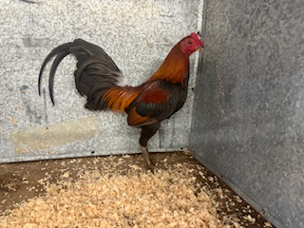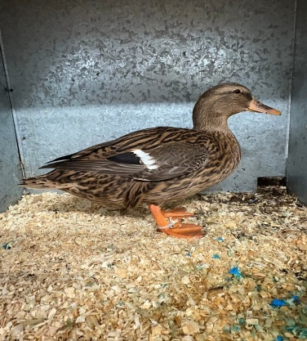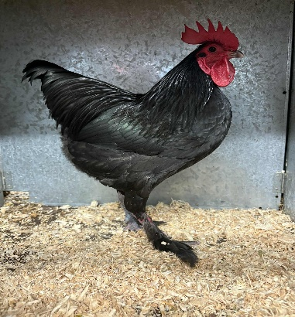
Our 2026 Champions

Woods Bros Reserve Champion Bird & Champion Hard feather OEG Black Red male, Champion Bird & Champion Waterfowl Akers Flock Normal Mallard Duck & Akers Flock Champion Soft feather Langshan Ckl

SUNDAY May 24th, 2026
The Euroa Agricultural Society Show Grounds. Poultry Pavilion, Euroa
Affiliated with the VPFA Inc

SHOW JUDGES

Mr Luke Dowling – Waterfowl and Juniors
Mr Hayden Stephens - Hardfeather
Mr Ian Bush - Softfeather
Mr Neil Penny – Specials
ENTRIES :- Entries close with the Show Manager – Mr Neil Penny,
0427 505291 On Thursday 14th May brownleghorn19@gmail.com
Pen numbers from show manager on morning of show.
EFT details are: CBA 063 682 1002 6642 if paying via EFT please
text receipt to Michael Holmes 0400 734278 once paid.

Euroa & District Poultry Club is utilising the VPFA Inc Standard Schedule. Please refer to www.vpfa.com.au for all class numbers and enter via attached entry form.

President: - | Mr M. Holmes P.O Box 1327, Wangaratta 3676 | M 0400 734278
Show Secretary: | Mr Neil Penny brownleghorn19@gmail.com | M 0427 505291

EUROA & DISTRICT POULTRY CLUB Inc. REGULATIONS

The Euroa & District Poultry Club is affiliated with the Victorian Poultry Fanciers Association (Poultry Stud Breeders & Exhibitors Victoria) and all exhibitors must be current financial VPFA members to exhibit this show.
VPFA memberships must be paid direct to the VPFA Ltd. Membership Secretary: VPFA Ltd Anne Beaty admin@vpfa.com.au

$55.00 | Seniors with e-journal
$15.00 | Juniors 16 and under (with e-journal)
$25.00 | C Class Membership - 2 clubs nominated
Fees 2026 (expires: 31.12.2026)
This show will be conducted according to the rules of the VPFA Ltd A copy of the same will be available from the secretary at the show, if required.

VPFA Journal Awards 2026, Hard feather – Indian Game, Soft feather – True Bantam, Waterfowl – Indian Runner AC Except White & Ancona

All pens disinfected prior to our Show.
- All exhibits must be the bonafide property of the exhibitor.
- All champions must be from first prize winners, with the exception of the reserve.
- Leg rings may be worn if no identifying marks on rings.
- Although the greatest care will be taken, the Euroa & District Poultry Club will not be responsible for and mistake, loss, injury, or damage from any cause what-so-ever.
- The committee reserves the right to reject any entry under the Rules and regulations of the VPFA rule 33 and relocate any judge if necessary due to availability & numbers.
- Any person causing annoyance by comments on the judge’s decision, or of insulting or unseemly behaviour, shall be liable to expulsion from the show and exhibits and/or awards disqualified.
- No person is permitted to handle or interfere with exhibits except for the judges and the stewards once judging has commenced.
- Exhibits must be penned by 9am on the day of the show (judging 9.30am)
- Member’s subscription $10.00 Seniors
$ 5.00 Juniors
$15.00 Family
Open you can direct credit to CBA 063 682 1002 6642
Entry fee: Members - $3.00 (11th entry and over $2.50 per entry).
Non-members - $3.50 per entry (11th entry and over $3.00 per entry)

Juniors
Entry fee: members – $1.00 per entry. Non-members - $1.50 per entry.
- A.O.R.V. Any other recognised variety, A.O.R.C. any other recognised colour, O.E.G. Old English Game, A.O.V. classes – (please state breed).
- Breakfast and light luncheon available at moderate cost.
- Exhibits will be judged to the approved standard APS2 and APS addendum.
- Donors can compete, but not win their own awards.
- A junior member shall be a person 6-16 years. They must handle their own exhibits on the day of the show unless prior arrangement with the show manager. Juniors may exhibit in senior or junior sections but not in both. Juniors showing in senior classes must pay senior entry fees.
- A junior exhibitor cannot show the same breed as a senior exhibitor from the same address.
- The committee reserves the right to change, or add to, the judge’s panel due to non- attendance of judges and/or excessive entries.

Awards
1st, 2nd, 3rd, place awards.
Best of breed sashes for 8 or more entries in any one breed. Best of breed trophy for 15 or more entries in any one breed.

VPFA donated SASH & Club Trophy for Champion Bird of Show

Sash & Trophy Champion Hardfeather Champion Softfeather Champion Waterfowl

Sashes
Champion Softfeather light breed standard
Reserve Champion softfeather light breed standard
Champion Softfeather heavy breed standard
Reserve Champion Softfeather heavy breed standard Champion Softfeather Bantam light breed
Reserve champion softfeather Bantam light breed Champion Softfeather Bantam heavy breed
Reserve Champion Softfeather Bantam heavy breed Champion Hardfeather standard breed
Reserve Champion Hardfeather standard breed Champion Hardfeather bantam OEG
Reserve Champion Hardfeather bantam OEG
Champion Hardfeather bantam Modern
Reserve Champion Hardfeather bantam Modern
Champion Hardfeather bantam (other than OEG & Modern)
Reserve Champion Hardfeather bantam (other than OEG & Modern) Champion Waterfowl
Reserve Champion Waterfowl
Champion & Reserve Muscovy
Champion & Res duck or drake heavy
Champion & Res duck or drake light
Cham & Res duck or drake bantam
Champion & Res goose or gander
Champion rare breed poultry
Champion rare breed waterfowl
Champion Eggs – VPFA Sash & res champion eggs Champion breeding pair
Champion turkey

Junior Trophies
Champion Junior, Reserve Champ Junior
Champion Large, Softfeather & Hardfeather Bantam & Waterfowl

Rare Breed Trophies
Braham Metry

Novice Trophies and Sashes as per separate sheet

PETER BLAKE Memorial Trophy for Champion Plymouth Rock of Show

Life Members: - Mrs B. Andrews (Dec), Mr D. Johnson (Dec), Mrs J.L. Newton (Dec) , Mr R. Holmes, Mr M. Holmes, Mrs L. Holmes, Mrs K. Holmes

Junior Sashes Champion junior Reserve champion junior
Champion softfeather standard Champion hardfeather standard Champion softfeather bantam Reserve champion softfeather bantam Champion hardfeather bantam
Reserve champion hardfeather bantam Champion waterfowl
Reserve champion waterfowl.

Trophies
Champion softfeather standard Reserve champion softfeather standard Champion softfeather bantam
Reserve champion softfeather bantam Champion hardfeather standard breed Res champion hardfeather standard breed Champion hardfeather bantam
Reserve champion hardfeather bantam Champion muscovy
Champion heavy waterfowl Champion light waterfowl Champion bantam waterfowl Champion rare breed waterfowl Champion rare breed poultry Champion Eggs
Champion breeding pair Champion turkey

Denis Johnson Memorial Trophy
Champion Wyandotte
2005 | - Ern Harden Columbian Ckl
2006 | - M & K Holmes white Bantam cock
2007 | - M & K Holmes white Bantam cock
2008 | - Lance Muddell white Bantam plt
2009 | - O & M Rees white Bantam Ckl
2010 | - Bruce Kerr white Bantam Plt
2011 | - M & K Holmes white Bantam Cock
2012 | - Sam Reid white Bantam Hen
2013 | - Ron Marsh Silver laced Hen
2014 | - Mst Hamish Smith Lge White Plt
2015 | - M & K Holmes white bantam Plt
2016 | - Cliff Murphy white bantam Plt
2017 | - K & N Fenaughty white bantam Plt
2018 | -Brad Gavenlock white Large Cock
2019 | -Brad Gavenlock white Large Plt
2020 | - No show
2021  2022 2023  2024 | - Fleur Hutchinson Columbian Bantam Plt  - M & K Holmes White Bantam Pullet  - Darren Griffiths White Bantam Ckl  - no show
2025 - Darren Griffiths White Bantam Ckl

Special Junior Cash Awards
Four $5.00 cash awards awarded to local junior exhibits on day of show in memory of Denis Johnson.

EGGS

VPFA Sash & Trophy: Champion Plate of Eggs

Sash: Reserve Champion Plate of Eggs

Class No. | Standard | Class No. | Bantam
5000 A | 4 Brown | 5001 A | 4 Brown
5000 B | 4 Tinted | 5001 B | 4 White
5000 C | 4 White | 5001 C | 4 Tinted
5000 D | 4 Blue or Green | 5001 D | 4 Blue or Green
5004 | Turkey  4 Turkey | 5002 | Duck  4 Standard
 |  | 5003 | 4 Bantam
5005 | Geese  4 Geese | 5006 | A.O.V  4 A.O.V. Type Eggs

5007 4 Internal/External Eggs – any kind (one egg to be broken and judged as per APS standards)

Decorated Egg Section


5007 eggs must solely be decorated by the exhibitor
MAJOR SPONSORS
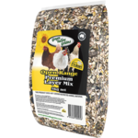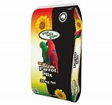

NOVICE SECTION
- All new exhibitors who have been showing for 5 years or less are eligible to enter in this section.
- A Novice may enter the same breed but not the same bird in both the Open and Novice Sections, so if you have two birds please feel free to put one in each.
- A Novice exhibitor is eligible if you have not won a major award at a PSBEV affiliated Poultry Club Show.
- All other rules are covered in General Section of Show Schedule and are relevant for the Novice Section.
- Judging Novice, Eggs, decorated eggs and colouring competition at 10.30am with a 11.30am presentation.
- Entry fee - Novice Section Free.
NOVICE – SENIOR

Class | Exhibit | Class | Exhibit
N1 | STD Softfeather Male | N2 | STD Softfeather Female
N3 | STD Hardfeather Male | N4 | STD Hardfeather Female
N5 | Bantam Softfeather Male | N6 | Bantam Softfeather Female
N7 | Bantam Hardfeather Male | N8 | Bantam Hardfeather Female
N9 | Waterfowl Drake | N10 | Waterfowl Duck
N11 | Gander or Turkey Male | N12 | Goose or Turkey Female
N13 | Trio | N14

NOVICE - JUNIOR

Class | Exhibit | Class | Exhibit
NJ1 | STD Male | NJ2 | STD Female
NJ3 | Bantam Male | NJ4 | Bantam Female
NJ5 | Waterfowl or Turkey Male | NJ6 | Waterfowl or Turkey Female
NJ7 | Trio
NJ8 | Blackest Male | NJ9 | Blackest Female
NJ10 | Whitest Male | NJ11 | Whitest Female
NJ12 | Friendliest Male | NJ13 | Friendliest Female
NJ14 | Most Fluffy Male | NJ15 | Most Fluffy Female
NJ16 | Funniest Looking Male | NJ17 | Funniest Looking Female
NC1 | Drawing of poultry | NC2 | Other artwork including Poultry
Colouring Competition: Prizes for 1st ,2nd and 3rd in age categories presented on the day
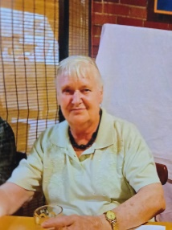
AWARDS Champion Novice the Joan Bjorksten Memorial trophy & Junior Novice-Sash & Caltex Fuel Voucher Reserve Champion Novice -Sash
Abbreviations | Meanings
STD | STD stands for Standard, which is a large bird.
Bantam | Bantams are smaller size or breed then STD
A.O.R.C. | A.O.R.C. stands for Any other recognized colour
A.O.R.V. | A.O.R.V. stands for Any other recognized Variety.
Trio | One male and two female of same breed

All Victorian Exhibitors must be a VPFA member registering on www.vpfa.com.au

EUROA & DISTRICT POULTRY CLUB Inc. EUROA & DISTRICT POULTRY CLUB Inc.
ENTRY FORM ENTRY FORM
EXHIBITOR COPY CLUB COPY

CLASS | PEN | EXHIBIT | CLASS | PEN | EXHIBIT

NAME………………………………………………...
ADDRESS…………………………………………….
…………………………………………P/C………….
PHONE NO. …………………………..
VPFA NO. ………………………….
MEMBERSHIP $..................
NO. OF ENTRIES…………. @ ………= $…………..
Total $..................
NUMBERS for LUNCHEON ………………….
NAME………………………………………………...
ADDRESS…………………………………………….
…………………………………………P/C………….
PHONE NO. …………………………..
VPFA NO. ………………………….
MEMBERSHIP $..................
NO. OF ENTRIES…………. @ ………= $…………..
Total $..................

Euroa & District Poultry club inc.
PO Box 1327
Wangaratta Vic 3676

