*** Rhode Island Club of Victoria.***

# 19th Annual Show

## Show Date Saturday 25th August 2018

Venue Ballarat Showground’s

**Show Manager Mr. Rod Lindsay**

**Show Secretary Mrs. Linda Kilpatrick**

**P.O Box 144R, Redan Vic 3350**

[lindakilpat1@outlook.com](mailto:lindakilpat1@outlook.com)

**Entries close Friday August 17th, or when the pavilion is full.**

**NO LATE entries,  NO PHONE entries, No changes on the day.**

*Please check with Linda that your entries have been received.*

Entry fees Open: $3.00 per bird.

**Juniors: $1.50 per bird in junior classes.**

**Membership $10.00 adults.**

**$5.00 juniors.**

Penning time. All birds to be penned by 9.30am. Pavilion will be opened at 7.00am. Birds may only be penned after 9.30am with the permission of the Show Manager. Birds may be penned on Friday (4.00pm – 8.00pm only) by prior arrangement with the show Manager.

**Judging time. Judging will commence at 10.00 am sharp.**

**Judge. Mr. Michael Homes**

*Please note the contact details for Ballarat Poultry society schedule if you are showing other than Rhode Islands (25/8/2018) Contact Tony Mann Ph 0418553984 or email tony@absolutepest control.com.au*

**The AGM of the RICA will be held in the “big Shed” at 10.30am. All members are invited to attend.**

**Rhode Island Club of Victoria.**

**Rules and regulations.**

All exhibitors should read these Rules and Regulations as they will be enforced by the show manager.

1. The society is affiliated with the VPFA and all Victorian resident exhibitors must be financial members of the VPFA.
2. If the show manager is absent for any reason the person delegated will fulfill the position of the show manager for whatever time necessary.
3. Exhibits cannot be removed from show pens after 9.30 am Saturday without the consent of the Show Manager.
4. The Rhode Island Club of Victoria will not be responsible for any mistake, accidents, loss or damage from any cause, though the greatest care will be taken.
5. The committee reserves the right to reject any entry without assigning a reason.
6. Any entry which appears sick or diseased may be ordered from the pavilion by the Show Manager.
7. The judge’s decision shall be final. Any person found guilty of causing annoyance by loud comments about a judge’s decision, or insulting or unseemly behavior shall be liable to expulsion from the show and their exhibits ordered from the show and any of their judged exhibits will be disqualified.
8. Any bird entered in the wrong class will be disqualified.
9. Birds may only be given water prior to judging, using the Ballarat Poultry Club watering cups.
10. No bird shall be fed in pens between 9.30 am and completion of judging. (Birds only to be fed grain. No feeding of bread or other feeds will be permitted.)
11. All birds entered in young bird classes must be under 12 months of age.
12. Birds penned with marker bands or other forms of markers will be disqualified.
13. The committee reserves the right to appoint a substitute judge if and where necessary.
14. If a junior exhibitor is living with a parent or guardian who also shows poultry, the junior must not show the same variety as the parent or guardian.
15. All junior exhibits must be **prepared, penned and unpenned** by the junior exhibitor.
16. Juniors can enter birds in both junior and senior classes. Exhibits entered in junior classes are eligible for junior awards only. Exhibits entered in Open classes pay Open class entry fees, and are eligible for Open Class awards only.
17. Junior class entries are to use the same schedule of classes as open, but to place a “J” in front of the numbers

AWARDS AND PRIZES.

**PRIZES AND SASHES;**

Champion Exhibit in Show John List $50, 1 Bag Peters Poultry Mix &

Australasian Poultry Subscription (12months)

Res Champion Exhibit in Show The Hay Market Ballarat $25 Gift Voucher

Skin, Ski and Surf –Ballarat - Gift

Champion Standard Possum Pets - Ballarat

Champion Bantam Laucke Feed Voucher

Champion Standard Red Laucke Feed Voucher

### Champion Standard White Laucke Feed Voucher

### Champion Bantam Red Neil Overall Memorial (Must be won 3 Times)

Ch Bantam White Laucke Voucher

Ch Standard Rose Comb G and A Vella - Prize

Ch Standard Single Comb McMahons & Sons shell Grit.

Ch Bantam Single Comb Bob French Memorial (Club award)

Ch Bantam Rose Comb G and A Vella - Prize

Ch Std. Red Single Comb F. DeGruchy Memorial Trophy

Champion Junior Exhibit. Skin Ski and Surf Ballarat / Peters pure animal food.

Reserve Champion Junior, N.G. Hunter Trophy/ INKA Flight Pestine.

Champion Exhibition Pair in Show. Sponsored by $50 Voucher - Vetafarm

Champion Pullet Pair in Show. Sponsored by $50 Voucher Vetafarm

Breeder Award for 2018 Sponsored by Vella Family

**All Champ’s will receive a bag of feed** Sponsored by Laucke Mills and Possum Pet Ballarat, Pet Stock Latrobe Street & Mair St Ballarat.

McMahon and Sons Point Lonsdale

**TROPHY ONLY**

Champion Bantam Red Rose Comb Sponsored by Vella Family

Champion Standard Red Rose Comb Sponsored by Vella Family

Reserve Champion Junior Sponsored by N.G.Hunter

Champion Junior Bird Sponsored by Skin Ski and Surf / INCA Flight

Inca-Pestene insect powder Trophy

**SASH ONLY**

Res. Champion Standard Rose comb

Res. Champion Bantam Rose comb

Res. Champion Standard Bird

Res. Champion Bantam

Res. Champion Standard Red

### Res. Champion Standard White

### Res. Champion Bantam Red

Res. Champion Bantam White

Res. Champion Exhibition Pair

Res. Champion Pullet Pair

All Reserve to receive a 5KG bag of feed from Peter’s Pure Animal Food.

A Sash will be provided for first in classes of 4 or more.

A Sash will be provided for second Classes of 8 or more

Prize cards will be issued for up to five places, depending on the number of entries in the class.

***The pullet pairs*** are presented as an evenly matched pair of pullets, of exhibition quality.

***The exhibition pairs*** are two birds which match the standard for exhibition.

***BREEDERS AWARD***

The Breeder’s Award will be awarded to the exhibitor who enters a cock, hen, cockerel and pullet into any one variety. The breeder’s top placed bird will be allocated points on the basis of how many exhibitors in that class. If there are five exhibitors then the first placed bird will be awarded five points, 2nd bird four points etc. in the event of a tie bonus points will be awarded for major awards to determine the winner.

[](http://www.google.com.au/url?sa=i&rct=j&q=&esrc=s&source=images&cd=&cad=rja&uact=8&ved=0ahUKEwjhsemIhsnUAhWMjZQKHTjoDU8QjRwIBw&url=http://www.onlinepetcart.com.au/bird-food/vetafarm-pellets.html&psig=AFQjCNFdmqlmdw7K9L9TTW3LfRh4MIH0Tw&ust=1497932097332874)

***Sponsored by Vetafarm***

Champion Exhibition pair in show Champion Pullet pair in show 2014 N.G. Hunter D. Yoxall

2015 K. George D. Yoxall

2016 N.G.Hunter D. Yoxall

2017 K.George K.George

We thank all our trophy donors, the full list has not been finalized at the date printing.

Late donations will be most acceptable.

Trophies and sashes provided subject to availability and entry numbers.

***Morning tea;***

It would be appreciated if members and visitors would support the Ballarat Poultry Club by supporting their morning tea and lunch.

[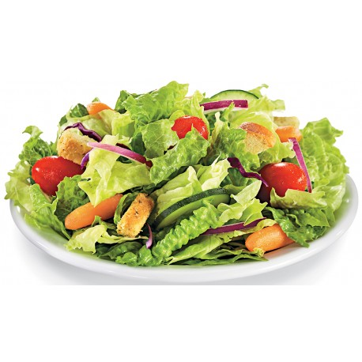](http://www.google.com.au/url?sa=i&rct=j&q=&esrc=s&source=images&cd=&cad=rja&uact=8&ved=0ahUKEwiAguaFu-DUAhUDH5QKHT9fC9UQjRwIBw&url=http://ghwoodoven.com.au/salads/22-garden.html&psig=AFQjCNE7wA6tDPFPBI0_OOLVKWYSloMc_A&ust=1498736525065809)

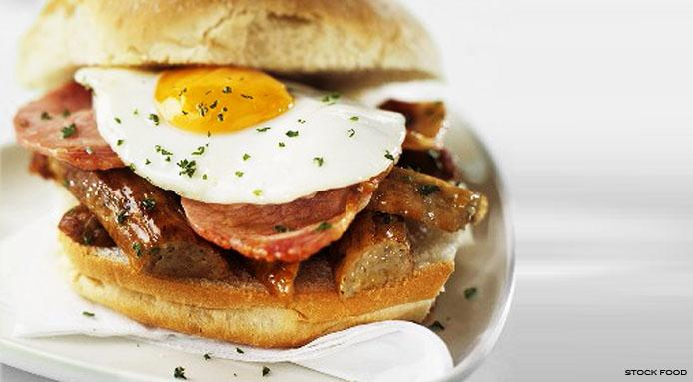

***Schedule of classes.***

### VARIETY Cock Hen Ckl Plt.

### Standard R.I. Red Rose comb 1320 1321 1322 1323

Standard R.I. Red Single comb 1324 1325 1326 1327

### Standard R.I. White Rose comb 1328 1329 1330 1331

Standard R.I. White Single comb 1332 1333 1334 1335

Bantam R.I. Red Rose comb 3376 3377 3378 3379

Bantam R.I. Red Single comb 3380 3381 3382 3383

Bantam R.I. White Rose comb 3384 3385 3386 3387

Bantam R. I. White Single comb 3388 3389 3390 3391

Exhibition Pair Standard A

Bantam B

Pullet Pair Standard C

Bantam D

WEIGHTS FOR STANDARD RHODE ISLAND REDS AND WHITES;

### Cock: 3.85kg Cockerel 3.40 kg

Hen 2.95 kg Pullet 2.50 kg

WEIGHTS FOR BANTAM RHODE ISLAND REDS AND WHITES;

Male 1020 – 1135 grams. Female 850 – 960 grams.

**Birds are to be judged to the Australian Poultry Standards Ed’n 2.**

***After the show***

***Many Hands Make Light Work! – We would appreciate if the exhibitors could scrape the shavings into a pile at the front of the pen, and remove water cups. Your assistance is appreciated in advance.***

**Previous Winners:**

**Champion bird in Show; Champion Standard Champion Bantam.**

2000: R. Lindsay. R. Lindsay G. Kemp.

2001: G. Kemp. G. Kemp. N. Hunter.

2002: G. & A. Vella. G. & A. Vella. N. Hunter.

2003: G. & A. Vella. G. & A. Vella. G. Krohn.

2004: N. Hunter. R. Lindsay N. Hunter

2005. G. Kemp G. Kemp K. George

2006 G. Krohn R. Overall G. Krohn

2007 GP & AJ Vella G P & A J Vella N. Hunter

2008 K. George K. George N. Hunter

2009 G. Krohn D. Yoxall G. Krohn

2010 R. Lindsay R. Lindsay G. Krohn

2011 K. George W. Peck K. George

2012 D. Yoxall G & A Vella D. Yoxall

2013 GP & AJ Vella GP & AJ Vella M. Gilmartin

2014 D. Yoxall D. Yoxall J.Brown

2015 K. George K. George N. Hunter

2016 N. Hunter D. Yoxall N. Hunter

2017 K. George K. George T.Milton

***Today’s Judge – Michael Holmes.***

I started showing at age 8 and judged my first agricultural show at Seymour at the age of 18.

I have judged each Royal throughout Australia along with many major poultry club and specialist shows including the National’s in 2000, 2004, 2008, 2012 and 2016. Major shows include Victorian Waterfowl Association, Leghorn, Australorp, Wyandotte and Langshan Club of Australia.

I have exhibited hard feather, including Modern Duckwings, OEG Duckwing and Black Reds, Waterfowl Rouen, Elizabeth, Buff Orpington, and White and Normal Mallards and Soft feather, Wyandottes in large Silver and bantam white, six colours of bantam leghorns, large white leghorns, langshans, Australorps, Guinea Fowl and Chinese Geese.

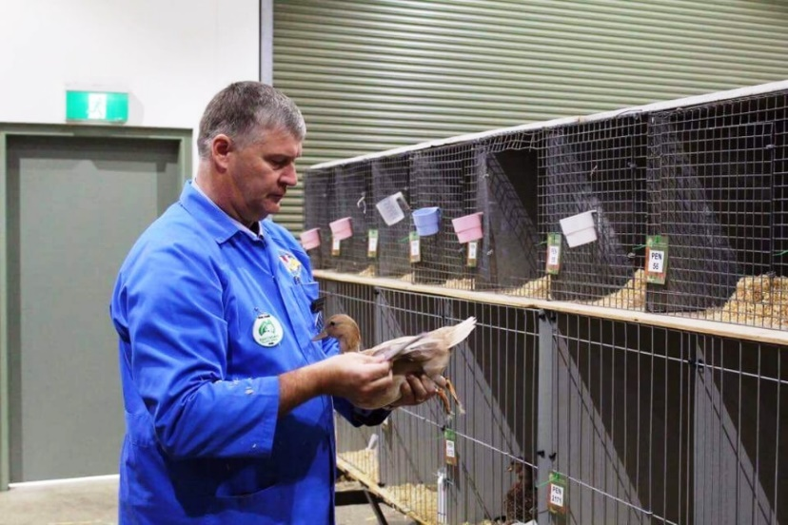

I’m currently on the Royal Melbourne Show poultry Committee, the Victorian Waterfowl Fowl Committee, President of Euroa Poultry Club and Leghorn Club of Victoria and show manager for Wangaratta Poultry club and the Victorian Poultry and Kennel Club. I’m also in my 4th 3 year term on the VPFA Ltd board in Victoria and are currently Treasurer.

As I started off as a junior I love assisting our new exhibitor’s and mentoring and supplying birds and eggs where I can and show at local Ag shows through to the Sydney and Canberra Royal and specialist club shows to see where my birds are at, but at all times supporting local shows and grass roots poultry.

I look forward to judging the Rhode Island Club in Ballarat and love staying for the talking chook chatter and friendship that occurs on these days.

***Michael Holmes***

[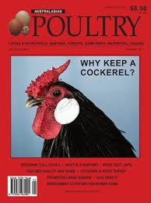](https://www.google.com.au/url?sa=i&rct=j&q=&esrc=s&source=images&cd=&cad=rja&uact=8&ved=0ahUKEwjUyp_shcnUAhVLG5QKHRWhAn4QjRwIBw&url=https://www.google.com.au/url?sa=i&rct=j&q=&esrc=s&source=images&cd=&ved=&url=https://shop.auspost.com.au/product/australasian-poultry-magazine-12-month-subscription-is-34245&psig=AFQjCNGJqCllkasJhYh2f916CNhHAmfspA&ust=1497932003478899&cad=rjt&psig=AFQjCNGJqCllkasJhYh2f916CNhHAmfspA&ust=1497932003478899)

RHODE ISLAND CLUB OF VICTORIA

[](http://www.google.com.au/url?sa=i&rct=j&q=&esrc=s&source=images&cd=&cad=rja&uact=8&ved=0ahUKEwjhsemIhsnUAhWMjZQKHTjoDU8QjRwIBw&url=http://www.onlinepetcart.com.au/bird-food/vetafarm-pellets.html&psig=AFQjCNFdmqlmdw7K9L9TTW3LfRh4MIH0Tw&ust=1497932097332874)We would like to thank all of valued sponsors for 2018

VetaFarm

Laucke Mills

Peter Pure Animal foods

Haymarket Ballarat

[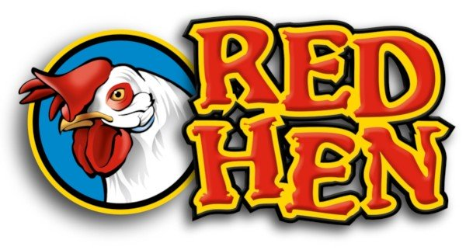](https://www.google.com.au/url?sa=i&rct=j&q=&esrc=s&source=images&cd=&cad=rja&uact=8&ved=0ahUKEwiLl4r0hMnUAhWBNJQKHefcArEQjRwIBw&url=https://www.yellowpages.com.au/sa/daveyston/laucke-mills-14183723-listing.html&psig=AFQjCNGADid9aCJreR58dAFs_rIKojTbFw&ust=1497931737068269)Skin Ski and Surf Ballarat

Australasian Poultry

Olive Grove Delicatessen

[](http://www.google.com.au/url?sa=i&rct=j&q=&esrc=s&source=images&cd=&cad=rja&uact=8&ved=0ahUKEwiJ8J39g8nUAhVIppQKHXsADGIQjRwIBw&url=http://www.bridgemall.com.au/business-directory/191/skin-ski-surf&psig=AFQjCNFSZNT7N-ZYWrO_zoLEXX-KtNJR3w&ust=1497931509441301)Possum Pets Ballarat

[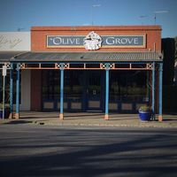](https://www.google.com.au/url?sa=i&rct=j&q=&esrc=s&source=images&cd=&cad=rja&uact=8&ved=0ahUKEwiq1OyOh8nUAhWBFJQKHapMDrYQjRwIBw&url=https://www.zomato.com/ballarat-vic/the-olive-grove-ballarat&psig=AFQjCNFmxCkRirvU8vZNO3mkQ5Xtyu5aMw&ust=1497932376145578)Mc Mahon and Sons

N Hunter

G and A Vella

[](https://www.google.com.au/url?sa=i&rct=j&q=&esrc=s&source=images&cd=&cad=rja&uact=8&ved=0ahUKEwj_9q-PhcnUAhWCspQKHafGCq4QjRwIBw&url=https://www.petshopboyz.com.au/products/Stock.asp?c=576&psig=AFQjCNGADid9aCJreR58dAFs_rIKojTbFw&ust=1497931737068269)Rod and Heather Lindsay

Petstock Latrobe St & Mair St Ballarat

Inca Flight-Pestine

John List

[](https://www.google.com.au/url?sa=i&rct=j&q=&esrc=s&source=images&cd=&cad=rja&uact=8&ved=0ahUKEwj00r_Ig8nUAhWEoJQKHciAA_AQjRwIBw&url=https://www.yellowpages.com.au/vic/ballarat/the-haymarket-13705832-listing.html&psig=AFQjCNGJWpm2fY54U90iFN3Ns7caKlfkNw&ust=1497931392925169)[](https://www.google.com.au/url?sa=i&rct=j&q=&esrc=s&source=images&cd=&cad=rja&uact=8&ved=0ahUKEwjU46K9hcnUAhVFE5QKHXFuAmUQjRwIBw&url=https://www.petdirectory.com.au/?page=profile&pid=1988&psig=AFQjCNH41cVfZTLXjmAdXtO9xM_h64qL3g&ust=1497931913407352)[](http://www.google.com.au/url?sa=i&rct=j&q=&esrc=s&source=images&cd=&cad=rja&uact=8&ved=0ahUKEwil1oC1icnUAhXDlZQKHcACBGgQjRwIBw&url=http://petshack.com.au/&psig=AFQjCNFbLISHSNoTJYPXSCpefQc-sv6K5A&ust=1497932991223609)[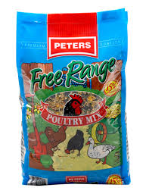](https://www.google.com.au/imgres?imgurl=http://www.peterspureanimalfoods.com/images/products/Peters_PoultryMix.jpg&imgrefurl=http://www.peterspureanimalfoods.com/products/poultry/food/free-range-poultry-mix.php&docid=uRNDbF_TE923cM&tbnid=187R2EpGxDCJYM:&vet=10ahUKEwiy_4K3hMnUAhVEHJQKHTGdACEQMwgyKBAwEA..i&w=420&h=546&bih=566&biw=1366&q=peters%20pure%20animal%20foods%20logos&ved=0ahUKEwiy_4K3hMnUAhVEHJQKHTGdACEQMwgyKBAwEA&iact=mrc&uact=8)

**Rhode Island Club of Victoria**

|  |  |  |
| --- | --- | --- |
| Class | Pen | Details --- Breed/variety/sex |
|  |  |  |
|  |  |  |
|  |  |  |
|  |  |  |
|  |  |  |
|  |  |  |
|  |  |  |
|  |  |  |
|  |  |  |
|  |  |  |
|  |  |  |
|  |  |  |
|  |  |  |
|  |  |  |
|  |  |  |
|  |  |  |
|  |  |  |
|  |  |  |
|  |  |  |
|  |  |  |
|  |  |  |
|  |  |  |
|  |  |  |
|  |  |  |
|  |  |  |
|  |  |  |

V.P.F.A. No................................

Telephone No ...................................................

Mr/Mrs/Ms.............................................................Address .........................…………………………..

................................................................................................................................. …………………

………entries @ .............. $ .............................

Membership $10/$5 $ .............................

Donation $ .............................

Lunch ……. @

TOTAL$ .............................

I Certify that the birds entered by me are my bona fide property and I agree to carry out and be bound by the Rules and regulations of this exhibition and the PSBEV.

Signed …………………………………………………………**Rhode Island Club of Victoria**

|  |  |  |
| --- | --- | --- |
| Class | Pen | Details --- Breed/variety/sex |
|  |  |  |
|  |  |  |
|  |  |  |
|  |  |  |
|  |  |  |
|  |  |  |
|  |  |  |
|  |  |  |
|  |  |  |
|  |  |  |
|  |  |  |
|  |  |  |
|  |  |  |
|  |  |  |
|  |  |  |
|  |  |  |
|  |  |  |
|  |  |  |
|  |  |  |
|  |  |  |
|  |  |  |
|  |  |  |
|  |  |  |
|  |  |  |
|  |  |  |
|  |  |  |

V.P.F.A. No....................................

Telephone No ...................................................

Mr/Mrs/Ms.............................................................Address................................................................

............................................................................................................................................................

……….entries @ .............. $ .............................

Membership $10/$5 $ .............................

Donation $ .............................

Lunch ……@

TOTAL $ .............................

**Your Notes and Observations from today’s show.**