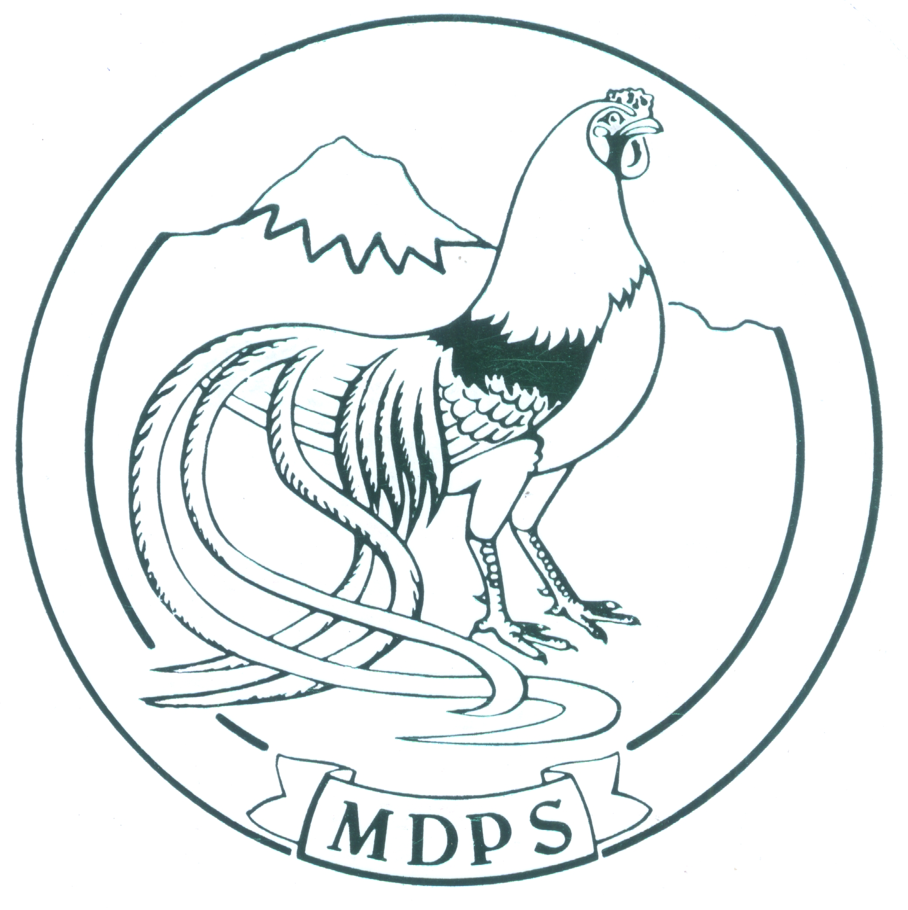
MOUNTAIN DISTRICT POULTRY SOCIETY VICTORIA INC

Annual Show 2018
Saturday 4th August 2018
Henderson Pavilion, Yarra Glen Showgrounds
Melway Ref. 275 B2

Affiliated with the V.P.F.A. Ltd

VPFA Standard Show Schedule V4.2
http://www.vpfa.com.au/standard-schedule/

Judging to commence at 9.15 A.M. sharp
Penning by 9.00 A.M. on day of show.
Shed open 7.00am

Morning tea and BBQ lunch available at reasonable prices

Entries Close Friday 27th July 2018
With The Secretary: Mr. D Riley
19 Elsie Grove Healesville 3777
Or Via email mdpsinc@yahoo.com.au

JUDGES
Softfeather | Mr. Nick Fenaughty
Hardfeather and Waterfowl | Mr. Rod Laverty
Major Awards | Both Judges

Mountain District Poultry Society Inc.

Office Bearers
President: | Brian Daniels
Vice President: | Russell Mason
Jnr Vice President: | Peter Lark
Secretary: | Doug Riley
Treasurer: | Kathleen Riley
Show Manager: | Peter Lark

Life Members

Mr W. Stanhope (dec) | Mrs G. Knight (dec)
Mr K. Mason O.A.M. | Mrs K. Ockwell
Mr A. Veerman | Mr P. Lark
Mr B. Daniels | Mr H.O. Stehn (dec)
Mr B Kerr | Mr D. Riley

Memberships
Senior: | $15.00
Junior: | $10.00
Family | $20.00

Entry Fees
Senior Members: | $2.00 Per Bird
Senior 15 Entries or more | $1.50 Per Bird
Junior Members: | $1.50 Per Bird
Junior 15 Entries or more | $1.00 Per Bird
All Non Members Senior & Junior | $3.00 Per Bird

Entries maybe paid by EFT to MDPS: Bendigo Bank:
BSB: 633 108 ACC Number: 138905070.
Please note your name with payment

Senior Awards
Champion Bird | Trophy and Sash
Reserve Champion | Trophy and Sash
Champion Waterfowl | Trophy and Sash
Reserve Waterfowl | Trophy and Sash
Champion Hard Feather Stnd | Trophy and Sash
Reserve Hard Feather Stnd . | Trophy and Sash
Champion STD Heavy Softfeather | Trophy and Sash
Reserve STD Heavy Softfeather | Trophy and Sash
Champion STD Light Softfeather | Trophy and Sash
Reserve STD Light Softfeather | Trophy and Sash
Champion S/F Bantam | Trophy and Sash
Reserve S/F Bantam | Trophy and Sash
Champion Hardfeather Bantam | Trophy and Sash
Reserve Hardfeather Bantam | Trophy and Sash

Sash Only
Champion Softfeather Bantam Light | Sash
Reserve Softfeather Bantam Light | Sash
Champion Softfeather Bantam Heavy | Sash
Reserve Softfeather Bantam Heavy | Sash
Champion O.E.G Bantam | Sash
Reserve O.E.G Bantam | Sash
Champion Modern Game Bantam | Sash
Champion O.E.G Standard | Sash
Champion A.O.V Hardfeather Standard | Sash
Champion Muscovy | Sash
Champion Heavy Breed Waterfowl | Sash
Champion Light Breed Waterfowl | Sash
Champion Bantam Waterfowl | Sash
Champion Junior Crested Bird | Sash
Champion Rare Breed | Sash
Champion Multi-colored or Patterned Bird | Sash

Junior Awards

Champion Junior Bird | Trophy and Sash
Reserve Junior Bird | Trophy and Sash
Champion Junior Large | Trophy and Sash
Reserve Junior Large | Trophy and Sash
Champion Junior Waterfowl | Trophy and Sash
Reserve Junior Waterfowl | Trophy and Sash
Champion Junior S/F Bantam | Trophy and Sash
Reserve Junior S/F Bantam | Trophy and Sash
Champion Junior H/F Bantam | Trophy and Sash
Reserve Junior H/F Bantam | Trophy and Sash
Juniors Use the Letter “J” In Front Of Class Numbers When Entering

P.S.B.E.V. Journal Awards for 2018

Hardfeather – Australian Pit Game
Softfeather – Plymouth Rocks
Waterfowl – Pekin
Rare Breed - Orpingtons

SPECIAL AWARDS

Champion TALL Bird in Show Trophy and Sash
Plaque for Champion Tall Bird To Be Won FiveTimes 2009- K. Harris, 2010– D. Hughes, 2011-MacDonald Bros, 2012-D.Hughes

CHAMPION WYANDOTTE OTHER THAN WHITE
Donated by members of the Wyandotte Club of Victoria Inc.
To be won four times before being won outright 2009 B. Kerr, 2010 B.Kerr, 2011 Bruce Kerr, 2012 B.Kerr

CHAMPION SOFTFEATHER RARE BREED IN SHOW
To be won three times before being won outright 2009 - Donvale Christian School, 2010– Donvale Christian School; 2011 Bruce Kerr, 2012 Donvale Christian School

CHAMPION HAMBURGH –ANY COLOUR
Donated by the Former Hamburg Club of Australia.
To be won five times before being won outright. 2010– I. Askew, 2011 Eaglevale poultry stud

MEMORIAL TROPHY A.B. CLARK .TROPHY
FOR CHAMPION LARGEFOWL IN SHOW
To be won Five times……...2011, Macdonald Brothers, 2015 I Askew, 2016 R. Mclaren

PERPETUAL TROPHY BEST LEGHORN IN SHOW
Donated by Keith Alday To be won Three times ....
1998 John Ferguson, 1999 Geoff Hester, 2000 No Entry, 2001 S. Gray, 2002 D. Griffiths, 2003 Browyn Gray, 2004 M & K Holmes, 2005 R.M. French, 2006 R.M. French, 2007 R.M. French, 2008 R.M. French, 2009 R.M. French, 2010 I. Askew, 2011 R.M. French

CHAMPION WATERFOWL IN SHOW
To be won Five times, 2009 D. Johnson, 2011 John Hunt, 2012 John Hunt, 2013 A. Flett, 2014 A. Flett, 2015 D. Wilson, 2016 M & K Holmes

BILL SMITH MEMORIAL TROPHY FOR CHAMPION HARDFEATHER IN SHOW (EX. MODERN GAME BANTAMS)
To be won Five times…2011; Geoff Mason, 2012, D.Hughes

Our ribbons are provided by:
Show Ribbons Online
www.showribbionsonline.com

RULES AND REGULATIONS

Please Read Carefully as they will be adhered to.

- All entries are received subject to the rules and regulations of this society and the V.P.F.A. Ltd.
- All Victorian exhibitors must be financial members of the V.P.F.A.Ltd
- All CKLS and PLTS to be under 12 months of ages at the date of this show.
- Pen numbers will be collected from the SECRETARY on the morning of the show.
- All exhibits must be penned by 9.00 a.m. on the day of the show as judging will commence at 9.15 a.m. sharp.
- NO EXHIBIT will be handled by the owner or any other unauthorized person once judging has commenced.
- The Society will not be responsible for any mistake, accident, loss or damage from any cause, although the greatest care will be taken.
- All entries must be accompanied by the full entry fee and no late entries will be accepted. All cheques and money orders must be made out to Mountain District Poultry Society Inc.
- All entries not accompanied by full entry fees, will be returned.
- Any exhibitor wishing to change or add to their entry on the day of show, will pay $5.00 per change or addition.
- The committee reserves the right to change or add to, the judge’s panel due to non-attendance of judges and/or excessive entries.
- Any exhibit entered in the wrong class will be DISQUALIFIED from the competition and any bird suffering from a CONTAGIOUS DISEASE will be removed from the pavilion and entry fees forfeited.
- It shall be the responsibility of the exhibitor to remove all watering utensils before judging commences.
- LEG BANDS, as long as non-identifying, will be allowed at this show.
- JUDGES shall be the only persons using JUDGING STICKS on the BIRDS.
- Any person found guilty of causing annoyance by loud comments on the decision of the judges, or of insulting or unseemly behavior, shall be liable to expulsion from the show and his /her exhibits will be disqualified and all prizes and monies will be forfeited.
- A junior shall be between the ages of 6 and 16 on the day of the show.
- Exhibitors in the junior section will only be eligible for awards in the junior section.
- A JUNIOR EXHIBITOR showing in the JUNIOR section, must exhibit a different breed/variety to ANY SENIOR EXHIBITOR residing at the same address
- JUNIORS can enter in the SENIOR section as long as they pay senior entry fees and exhibit a different breed/variety to the junior section.
- Any SENIOR found helping a JUNIOR within the surrounds of the POULTY PAVILION, will have his/ her exhibits disqualified unless prior permission is obtained from the SHOW MANAGER.
- Please fill in both sides of the entry form.
- Where eight or more birds are entered in a class, a best of breed sash will be awarded.
- When entering in the A.O.R.C., A.O.R.V classes, please specify breed and/or color as eight or more of the one breed or color will constitute and additional class.
- JUNIORS WHEN ENTERING PLACE THE LETTER ‘J’ IN FRONT OF THE CLASS NUMBER.

MOUNTAIN DISTRICT POULTRY SOCIETY THANKS OUR MAJOR SPONSOR
GREEN VALLEY GRAINS

Club ………………………………………….

Class | Pen | Details --- Breed/variety/sex

V.P.F.A. No…………or One Day Exhibitor permit if not a VPFA Member $10.00 Permit $ …………………….
……. entries @ …............. $ ………...................
Membership $ ………..................
Donation $.............................
Lunch …..... @ $........... $ ……………………. TOTAL $..............................

Mr./Mrs./Ms........................................................
Address……….……………………………………
.................................................. …………………
Email: ………………………………………………
Telephone No ……………………......................
I Certify that the birds entered by me are my bona fide property and I agree to carry out and be bound by the Rules and regulations of this exhibition and the VPFA Ltd.

Club …………………………………………

Class | Pen | Details --- Breed/variety/sex

V.P.F.A. No…………or One Day Exhibitor permit if not a VPFA Member $10.00 Permit $.................................
……. entries @ …............. $ ………...................
Membership $ ………..................
Donation $.............................
Lunch …..... @ $........... $ ……………………. TOTAL $..............................

Mr./Mrs./Ms........................................................
Address……….……………………………………
.................................................. …………………
Email: ………………………………………………
Telephone No ……………………......................

Signed………………………………………

