Alf Woods Testimonial Show

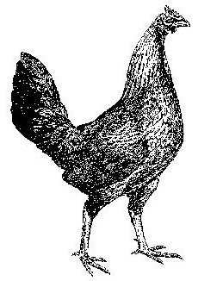
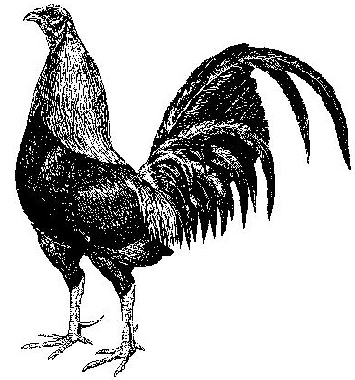
Old English Game Fowl Club of Australia Inc
29th Annual Show Ballarat Vic

21st & 22th July 2018
BALLARAT POULTRY PAVILION
BALLARAT SHOWGROUNDS
Cnr Creswick Rd & Howitt St, Ballarat, Vic
(Entry is via Howitt Street just before White Street)

JUDGES
Div 1 Large & Div 3 Bantams – Tony Davis (NSW)
Div 2 Large & Div 2 Bantams – Terry Politch (QLD)
Div 3 Large & Div 1 Bantams – Steve Hendrickson (Qld)

Entries close on Tuesday 10th July 2018
PAYMENT MUST ACCOMPANY ENTRIES
Please post all entries with Payment to the Show Secretary Michael Paterson,
31 One Tree Hill Road, Ferny Creek, Vic 3786 or mpaterson@probuild.com.au
Phone: 0418 306 273

EFT PAYMENTS ALSO ACCEPTED – BSB 032 543 ACCOUNT 275939
REFERENCE (Name of Exhibitor)

Membership: $30 per annum – DUE 1ST JULY 2017

Entry Fee: $3 per entry, MEMBERS ONLY

Birds can be penned on Friday, 20th July from 1.30pm until 6.30pm and on
Saturday, 21st July from 6.30am until 9.00am SHARP.
The show will conclude at 10.00am Sunday, 22nd July or at the close of the Auction after a brief address from the President.

All entries are made subject to the rules of the club
Exhibits must be healthy and show no signs of recent dubbing.
All fowls will be inspected prior to judging, any bird that is deemed not healthy or is showing signs of recent dubbing will be removed from the pavilion.

Chief Stewards: Tony Mann & Norm Hand
Show Secretary: Michael Paterson
Auction Steward: Albert Veerman

AUCTION (Helmsman) – 8.00am to 9.45am Sunday, 22nd July
Auction Pens: $10 (No commission from sales, full proceeds retained by seller)
Auction entries must be indicated on the entry form to secure an auction pen

Catering will be available at the Pavilion at reasonable prices
All care will be taken to ensure that exhibits are secure, but you enter at your own risk.

ACCOMMODATION
- Mid City Motel, 19 Doveton St North, Ballarat Central, 03 5327 7588, Website www.ballaratmidcity.com.au and mention OEG Club of Australia to receive a small discount.
- For more Motel options email Tony Mann at tony@absolutepestcontrol.com.au or ring Tony on 03-5342-8272 (AH) or 0418-553-984.
PRESENTATION DINNER
Saturday, 6.30pm at Hydrant Food Hall
3 McKenzie St, Ballarat Vic 3350
Cost $40.00 per head set menu alternate drop entrée and main, dessert available from the menu and coffee. Children’s menu for 12 & under from reasonable prices.
Members are required to indicate numbers attending and include payment with the entry form. This will ensure that all are catered for as the Club must indicate the number attending a week before the event.

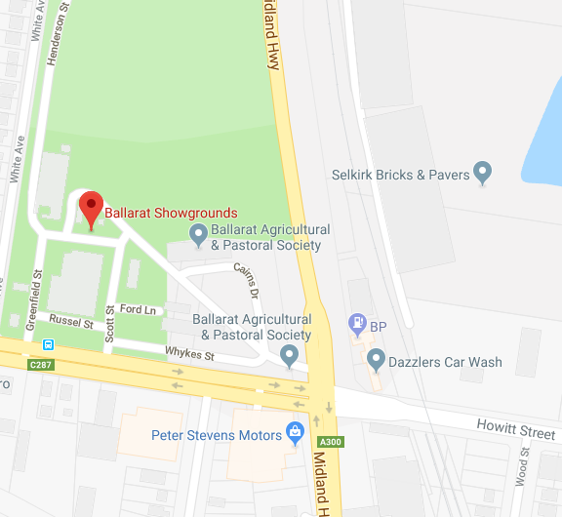

Grand Champion Bird of Show
Athol Pengilley Memorial Trophy
Special Cash Prize
Trophy Sponsored by Peter Irvine & Tim Polley
Tri Colour Sash & $200 Cash Prize
Sponsored by Dr Robert Sheen, Peter Irvine & Luke Nichol.

Reserve Champion Bird of Show
Special Cash Prize
Trophy, Tri Colour Sash Sponsors OEG Fowl Club of Australia
$100 Cash Prize
Sponsored by Norm Hand, Bill & Lois Battley

Patron’s Trophies
Best Large Cock in Show
Best Bantam Cock in Show
Sponsored by Club Patrons – Mr John Gibson, Mr Les McCoy, Dr Rob Sheen & Mr Alf Woods
Champion Large Fowl  Doug Waugh Memorial Trophy  Trophy and Sash Sponsored Glover Family | Champion Bantam  Alf Wood Tribute Trophy  Trophy and Sash, Sponsored by Matt Porter
Reserve Champion Large Fowl  Trophy and Sash  Sponsored by Mick O’Connell | Reserve Champion Bantam  Trophy and Sash  Sponsored by Tim Tydd
Champion Division 1 Large  Trophy, Sash & $80.00 Cash prize  Sponsored by Tony & Tracy Johnson  Special $100 for the most successful exhibitor Div 1 Large  Sponsored by Tony & Tracy Johnson | Champion Division 1 Bantam  Trophy Sponsored by Frank Sawyer  Sash & $80.00 Cash prize  Sponsored by Anthony Mountney
Champion Division 2 Large  Trophy, Sash & $80.00 Cash prize  Sponsored by Michael Hall  Champion Division 3 Large  Trophy, Sash & $80.00 Cash prize  Sponsored by Phillip Joynson  Reserve Champ Division 1 Large  Trophy, Sash & $50.00 Cash prize  Sponsored by Anthony Klatt  Reserve Champ Division 2 Large  Trophy, Sash & $50.00 Cash prize  Sponsored by Phillip Joynson  Reserve Champ Division 3 Large  Trophy, Sash & $50.00 Cash prize  Sponsor Jakyb Sharman | Champion Division 2 Bantam  Trophy, Sash & $80.00 Cash prize  Sponsored By Michael Paterson  Champion Division 3 Bantam  Trophy, Sash & $80.00 Cash prize  Sponsored By Sean Phillis & Kevin Gass  Reserve Champ Division 1 Bantam  Sash & $50.00 Cash prize Sponsored by Sean Phillis & Tim Polley  Reserve Champ Division 2 Bantam  Trophy, Sash & $50.00 Cash prize Sponsored by Milton Denning  Reserve Champ Division 3 Bantam  Trophy, Sash & $50.00 Cash prize Sponsored by Dr Rob Sheen
Division 1 - Large  Champion Cock, Hen, Cockerel & Pullet  Trophies & $20.00 Cash prizes  Sponsored by Scamp & Huges | Division 1 - Bantam  Champion Cock, Hen, Cockerel & Pullet  Trophies & $20.00 Cash prizes  Sponsored by Rob Maloney,Gordon Bradley &Dennis Knight
Division 2 - Large  Champion Cock, Hen, Cockerel & Pullet  Trophies & $20.00 Cash prizes  Sponsored by Chris Jaeger and John Gawned | Division 2 - Bantam  Champion Cock, Hen, Cockerel & Pullet  Trophies & $20.00 Cash prizes  Sponsored by Michael Demeter & Ian Nash
Division 3 - Large  Champion Cock, Hen, Cockerel & Pullet  Trophies & $20.00 Cash prizes each  Sponsored by Chris Jaeger and John Gawned | Division 3 - Bantam  Champion Cock, Hen, Cockerel & Pullet  Trophies & $20.00 Cash prizes  Sponsors By Bruce Paterson & Grant Peel
Champion Breeding Pair of Show  Trophy is a Signed copy of James Bishops book  Sash & 25.00 Sponsored by Laurie Barber  Champion Breeding Pair Large  Trophy, Sash & $30.00 Cash prize  Sponsored by Brad Power and Harry Bottomly  Champion Breeding Pair Bantam  Trophy, Sash & $30.00 Cash prize  Sponsored by Graeme Kemp  Champion Junior Exhibit  Trophy, Sash & $25.00  Sponsored by Davis Game Fowl Stud | Champion Large Fowl Female of Show  Trophy donated by Anonymous Member Valued at $250  Best Duckwing Bantam  Noeleen Battley Memorial Trophy  Trophy and $50 cash Sponsored by Tony Mann  FabioTrophy  Champion Large Golden Duckwing Male  Trophy and $50 cash Sponsored by Tony Mann  Reserve Champion Junior Exhibit  Trophy, Sash & $25.00  Sponsored by Davis Game Fowl Stud
Rosettes for best of colour
where 8 or more of a colour are exhibited
Best of Colour awards will receive a rosette.
Special once off cash prizes for
Champion Ginger Fowl Or Bantam of show $100 sponsored by Mike Ryan
Champion Grey Fowl or Bantam of show $100 sponsored by Daniel Cook
Special Cash Prizes of $50.00
On aggregate points for
The Most Successful Exhibitor from each State
Queensland - Sponsor Sean Phillis New South Wales - Sponsor Carl Oats
Victoria - Sponsor Barry Bilton Tasmania - Sponsor Brian Bennett
Western Australia – Sponsor Bill Harvey
South Australia – Sponsor Nathan Watson
Northern Territory – Sponsor OEG Fowl Club of Aust.
Prize Cards will be awarded for 4th in classes with 12 or more entries
Prize Cards will be awarded for 5th in classes of 16 or more entries
The Committee of the Old English Game Fowl Club Inc. wishes to thank all the sponsors for their support, it is greatly appreciated and ensures the annual club show will be a success.

Auction to be held on the dinner night with items donated by
- Barry Bilton (Mystery collector’s Item)
- Rob Monement Pair of outside Game Fowl ornaments
- Rob Monement Judging stick
- Signed copy of James Bishops book “This Celebrated Race of Fowls” signed by James Bishop and Alf Woods acknowledging Alf’s Testimonial Show.
- Chris White Pair of Large Fowl
All proceeds to the club.

Old English Game Fowl Club of Australia: Annual Show
OEG Large: Division 1 | Class
 | Cock | Hen | Ckl | Plt
Black Red (Dark Leg) | 1 | 2 | 3 | 4
OEG Large: Division 2 | Class
Duckwing (Light Leg) | 5 | 6 | 7 | 8
Silver, Golden, Birchen and Blue
Duckwing (Dark Leg) | 9 | 10 | 11 | 12
Silver, Golden, Birchen and Blue
Blue Red (Dark Leg) | 13 | 14 | 15 | 16
Blue Red (Light Leg) | 17 | 18 | 19 | 20
Black Red (Light Leg)  Partridge L/L females | 21 | 22 | 23 | 24
Wheaten  Black Tail, Blue Tail and White Tail |  | 25 |  | 26
White or Pile (Any Colour) | 27 | 28 | 29 | 30
Includes Self White, Smock, Streaky and Robin Breasted Blood-wing, Lemon, Custard etc
OEG Large: Division 3 | Class
Ginger (Light Leg) | 31 | 32 | 33 | 34
Includes Ginger Red, Ginger Pile etc
Ginger (Dark Leg) | 35 | 36 | 37 | 38
Includes Red Quill, Ginger Red, Ginger Pile etc
Brown Red | 39 | 40 | 41 | 42
Includes Brown Breasted Brown Red, Streaky Breasted Orange Red etc
Black Breasted Black Red | 43 | 44 | 45 | 46
Crow-wing Black Red
Brown Breasted Yellow Birchen | 47 | 48 | 49 | 50
Grey (Any Colour) | 51 | 52 | 53 | 54
Includes Dark Grey, Streaky Breasted Grey, Mealy Grey etc
Creel or Cuckoo | 55 | 56 | 57 | 58
Includes Cuckoo, Gold, Silver and Blue Creel, Mackerel (sport from Creel x Creel) etc
Dun (Any Colour) | 59 | 60 | 61 | 62
Includes Self Blue, Red, Yellow, Honey and Silver Dun etc
Black (Any Colour) | 63 | 64 | 65 | 66
Includes Self Black, Furnace, Polecat and Brassy Back
Spangle (Any Colour) | 67 | 68 | 69 | 70
Any ground colour with spangles
Muff | 71 | 72 | 73 | 74
Any Colour
Tassel | 75 | 76 | 77 | 78
Any Colour
Henfeather | 79 |  | 80
Any Colour
Any Other Colour (state colour)  Note: Includes Splash/Harlequin | 81 | 82 | 83 | 84
Large Breeding Pair | 85
OEG Bantam: Division 1 | Cock | Hen | Ckl | Plt
Black Red (Light Leg) | 86 |  | 87
Wheaten Black Tail |  | 88 |  | 89
Blue Red (Light Leg) | 90 |  | 91
Wheaten Blue Tail or White Tail |  | 92 |  | 93
OEG Bantam: Division 2 | Class
Black Red (Dark Leg) | 94 |  | 95
Partridge (Dark Leg) |  | 96 |  | 97
Partridge (Light Leg) |  | 98 |  | 99
Blue Red (Dark Leg) | 100 | 101 | 102 | 103
Blue Red (Light Leg) females |  | 104 |  | 105
Spangle (Any Colour) | 106 | 107 | 108 | 109
Any ground colour with spangles
Duckwing (Light Leg) | 110 | 111 | 112 | 113
Silver, Golden, Birchen and Blue
Duckwing (Dark Leg) | 114 | 115 | 126 | 127
Silver, Golden, Birchen and Blue
White or Pile (Any Colour) | 128 | 129 | 130 | 131
Includes Self White, Smock, Streaky and Robin Breasted Blood-wing, Lemon, Custard etc
OEG Bantam: Division 3 | Class
Brown Red | 132 | 133 | 134 | 135
Includes Brown Breasted Brown Red, Streaky Breasted Orange Red etc
Black Breasted Black Red | 136 | 137 | 138 | 139
Crow-wing Black Red
Brown Breasted Yellow Birchen | 140 | 141 | 142 | 143
Ginger (Light Leg) | 144 | 145 | 146 | 147
Includes Ginger Red, Ginger Pile etc
Ginger (Dark Leg) | 148 | 149 | 150 | 151
Includes Red Quill, Ginger Red, Ginger Pile etc
Grey (Any Colour) | 152 | 153 | 154 | 155
Includes Dark, Streaky Breasted, Mealy Grey etc
Self Blue | 156 | 157 | 158 | 159
Dun (Any Other Colour) | 160 | 161 | 162 | 163
Includes Red, Yellow, Honey and Silver Dun etc
Black | 164 | 165 | 166 | 167
Self Black
Furnace, Polecat and Brassy Back | 168 | 169 | 170 | 171
Creel - Gold and Silver | 172 | 173 | 174 | 175
Cuckoo (Any Colour) | 176 | 177 | 178 | 179
Includes Cuckoo, Blue Creel, Mackerel (sport from Creel x Creel) etc
Muff | 180 | 181 | 182 | 183
Any Colour
Henfeather | 184 |  | 185
Any Colour
Any Other Colour (state colour)  Note: Includes Splash/Harlequin | 186 | 187 | 188 | 189
Bantam Breeding Pair | 190

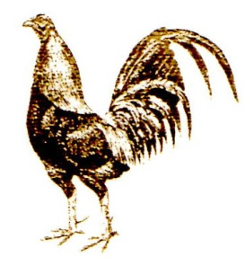

OLD ENGLISH GAME FOWL CLUB OF AUSTRALIA INC.

MEMBERSHIP APPLICATION / RENEWAL

(Please print clearly)

I ............................................................................... of ..............................................................
(Name of applicant) (No & Street)

............................................................................ ........................ ...............................
(Town or suburb) (State) (Postcode)

Phone ………………………………………….. Email …………………………………………………………………………...

apply to become a member of the Old English Game Fowl Club of Australia Inc.

My subscription of… (Tick appropriate box)
□ $30.00 is enclosed for yearly membership, Renewal due in July each year.

I agree to uphold the ideals of the Old English Game Fowl Club of Australia Inc. and acknowledge the authority of Herbert Atkinson who was responsible for the formation of the Oxford Association in 1885. I accept the illustrations of Herbert Atkinson as the true interpretation of the standard for Old English Game as acclaimed by the Australian Poultry Standards.
I agree to respect the views of other members and accept their variance of opinion in the context of the above mentioned ideals.

I shall not wilfully in any way act in a manner prejudicial to the interests of the Club and as a member I will respect and uphold the Club's ideals at all times.

Signature of Applicant .......................................................................... Date ...........................

Please forward this application together with payment to:

Old English Game Fowl Club of Australia Inc.
c/o Michael Paterson,
31 One Tree Hill Road, Ferny Creek,
Vic 3786

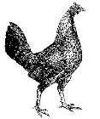
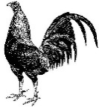
Old English Game Fowl Club of Australia Inc.
Ballarat 2018 Entry Form

 | CLASS # | DESCRIPTION | PEN #
1
2
3
4
5
6
7
8
9
10
11
12
13
14
15
16
17
18
19
20
21
22
23
24
25
 |  | Total of Entry Fees @ $3.00 each $
 |  | Membership Fees – Completed form to be returned $
 |  | Presentation Dinner / Social Function: adult @ $40. child @ $20. $
 |  | Donation/sponsorship $
TOTAL $
EFT PAYMENTS: BSB 032 543 Account 275939 Reference: ___________________
Please indicate number of Auction Pens required: _________
Auction Pens to be confirmed & paid to the Show Secretary M Paterson on Sat. 21st July prior to the AGM
Exhibitor’s Name: _______________________________________________________________________
Address: ____________________________________________ State: _________ Postcode: _________
Phone Nº: ____________________ Email: ___________________________________________________
Entry fees & Presentation Dinner payment to be included with entry form.
All monies due to be made payable to the Old English Game Fowl Club of Australia Inc.
Entries close 10th July 2018. Please post entries to Secretary: Michael Paterson,
31 One Tree Hill Road, Ferny Creek, Vic 3786, Phone: 0418 306 273
ENTRY PAYMENT MUST ACCOMPANY ENTRIES

